Day in the Life of the Hudson River 10/14/21
PIERMONT PIER, PIERMONT
RIVER MILE: 25.4
Salt Front: ~ RM 49
Lamont Doherty Earth Observatory– Margie Turrin, Laurel Zaima and 7 helpers
Tappan Zee High School, 20
Spring Valley High School, 11
Clarkstown South High School, 10
Clarkstown North High School, 3
Latitude 41.043189 N & Longitude – 73.89595 W

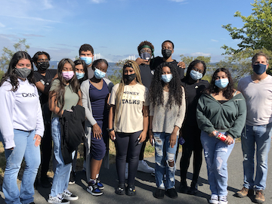 | 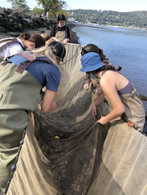 | 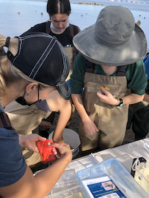 | 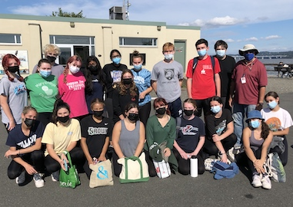
Spring Valley High School Seining & Fish ID with Clarkstown Tappan Zee High School

Location: Piermont Pier, Piermont, Rockland, NY
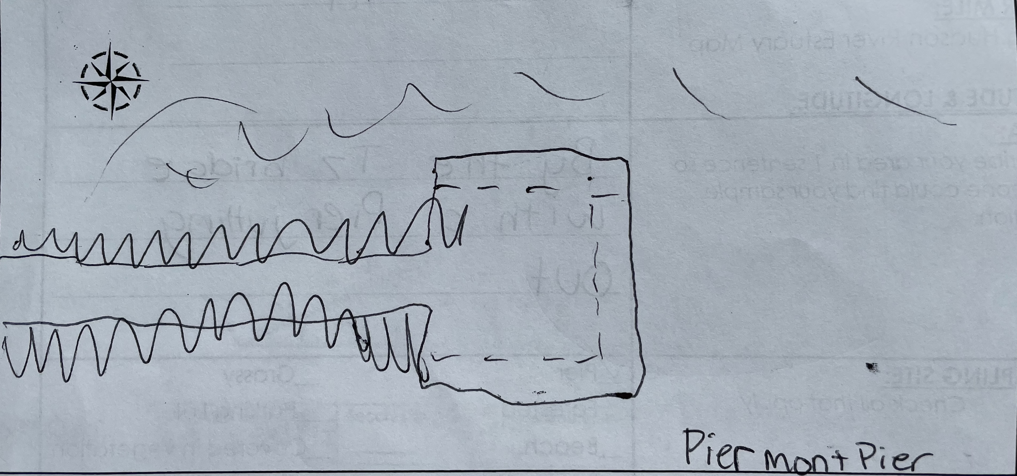
Area: Human made fishing/shipping pier at the east end, long pier with paved roadway and vegetated strip along both sides
Surrounding Land Use: 80% Urban/Residential; 20% Forested
Sampling Site: Pier, roadway in center of whole pier, parking area at the end, plants and trees along side. Shoreline riprap, collected wood in area and piping entering river on the south of sampling site
Water Depth: Varied by location on the pier and by the tide
Plants in area: 15% sumac and other plants; 85% phragmites; no submerged aquatic plants in water
River Bottom: Sandy, rocky bottom with phragmites growing in or near the water

ITEM |  | Time |  | Reading |  |  |  |  |  |  | Comments
Physical
Air Temperature.: |  | 9:12 AM  10:09 AM  9:47 AM  11:15 AM  11:17 AM  12:41 PM |  | 22.5 º C  26.1 º C  34.5 º C  29 º C  31.1 º C  24 º C |  |  |  | 72.5 º F  78.98 º F  94.1 º F*  84.2 º F  87.98 º F  75.2 º F |  |  | *seems a little hot, maybe the thermometer was left in the sun
Wind Speed: |  | 9:12 AM  9:19 AM  9:31 AM  9:35 AM  9:47 AM  9:47 AM  10:09 AM  10:14 AM  11:10 AM  11:13 AM  11:17 AM  12:33 PM  12:33 PM |  | 2 mph  Beaufort 1 (1-3 mph)  2.4 mph  Beaufort 1 (1-3 mph)  2.2 mph  Beaufort 1 (1-3 mph  4.35 mph  Beaufort 1 (1-3 mph)  3.4 mph  Beaufort 2  3.63 mph  8.5 mph  Beaufort 2 |  |  |  | South  South  South  South  North  North  Northeast  Northeast  Northwest  Northwest  North  Northeast  Northeast
Weather today |  | No Rain  9:15 am- clear <25%,  9:27 am- clear < 25%, sunny, foggy morning  9:47 am – partly cloudy (26-50%)  10:04 am - clear < 25%  11:12 am – clear <25%  12:24 PM- partly cloudy (26-50%)
Weather past 3 days: |  | No rain, foggy mornings, partly cloudy, sunny , 60-70s
Tides- |  | Low Tide |  | Water Depth (cm) |  |  |  | Rising/Falling/Still |  |  | Rate of Change (cm/min)
Station 1  Station 2 |  | 8:57 am  9:49 am  10:53 am  12:13 pm  9:00 am  9:47 am  10:48 am  12:14 pm |  | 246.4 cm  237 cm  211 cm  211 cm  360 cm  343 cm  334 cm  346 cm |  |  |  | -  Ebb  Ebb  Still  -  Ebb  Ebb  Flood |  |  | -  0.180 cm/min  0.406 cm/min  0 cm/min  -  0.362 cm/min  0.148 cm/min  0.140 cm/min
Current- |  | Time |  | cm/second |  |  |  | North/South |  |  | Ebb/Flood/Still
Low tide: 11:46 am  High tide: 5:44 pm |  | 9:33 am  9:20 am  9:47 am  10:28 am  10:48 am  11:30 am  12:14 pm  12:50 pm |  | 21.09 cm/sec, 0.41 knots  19.3 cm/sec, 0.375 knots  34.4 cm/sec, 0.669 knots  35.56 cm/sec, 0.69 knots  30.3 cm/sec, 0.589 knots  17.3 cm/sec, 0.337 knots  20.8 cm/sec, 0.40 knots  29.8 cm/sec, 0.579 knots |  |  |  | South  South  South  South  South  South  North  North |  |  | Ebb  Ebb  Ebb  Ebb  Ebb  Ebb  Flood  Flood
Water Temperature- |  | 9:00 am  10:15 am  10:17 am  10:22 am  10:53 am  10:55 am  12:12 pm  12:13 pm |  | 20 º C, 20 º C  21 º C  21 º C  21 º C  22 º C  21 º C  24 º C  22 º C |  |  |  | 68 º F, 68 º F  69.8 º F  69.8 º F  69.8 º F  71.6 º F  69.8 º F  75.2 º F  71.6 º F
Turbidity- Long Sight Tube |  | 10:54 am  10:55 am  12:31 pm  12:49 pm |  | 49.70 cm  48.2 cm  26.8 cm  26.2 cm
Chemical
Salinity- |  | 9:00 am  9:15 AM  10:17 am  10:35 am  10:53 am  12:12 pm  12:13 pm |  | Hydrometer  7 ppt  7 ppt  6 ppt, 6 ppt  6 ppt  6 ppt, 5 ppt  6 ppt, 6 ppt  6 ppt |  |  |  | Refractometer  4.8 ppt  4.8 ppt  6 ppt  6 ppt  5.5 ppt, 5ppt  5 ppt
DO – Hach Drop count |  | Time |  | Temp |  |  |  | ppm DO |  |  | % saturation
 |  | 9:00 am  10:15 am  10:17 am  10:42 am  10:53 am  10:55 am  12:12 pm  12:13 pm  12:39 pm |  | 20 º C  21 º C  21 º C  21 º C  22 º C  21 º C  24 º C  22 º C  24 º C |  |  |  | 8 ppm  7 ppm  12 ppm  7 ppm  7 ppm  6 ppm  12 ppm  13 ppm  12 ppm |  |  | 88%  75%  135%  75%  80%  65%  140%  145%  140%
pH – Color Match Kit |  | 9:00 am  10:17 am  10:53 am  12:12 pm |  | 7.5, 7.1  7.5, 7.3  7.5, 7.2  7.5, 7.2
Nitrates- Hach |  | 9:00 am  9:10 am  10:15 am  10:17 am  10:53 am  10:55 am  12:12 pm  12:13 pm |  | 0 ppm, 0.8 ppm  0ppm  0.8 ppm, 0.8 ppm  0.88 ppm  0.44 ppm  0.8 ppm  0.44 ppm  0.8 ppm
Phosphates- Hach |  | 9:00 am  10:53 am  10:55 am  12:12 pm  12:28 pm |  | 0.2 ppm, 0.2 ppm  0 ppm  0.14 ppm  0.15 ppm  0.15 ppm
Alkalinity- Hach |  | 9:00 am  ~10:30 am 12:12 pm |  | 72 ppm  340 ppm  160 ppm
Biological
Fish |  | Number |  | Name |  |  |  | Length of longest |  |  | Length of smallest
8:40-9:40am  10:00am  10:30am  11:44am  12:00pm |  | 3  6  1  11  9  3  1  1  2  15  1  2  43  2 |  | Fry  Striped Bass  White Perch  Atlantic Silverside  Atlantic Silverside  Striped Bass  Striped Bass  Fry  Striped Bass  Atlantic Silverside  White Perch  Striped Bass  Atlantic Silverside  White Perch |  |  |  | 2 cm  11.4 cm  11.2 cm  11 cm  11.3 cm  9 cm  10 cm  1.5 cm  9 cm  9 cm  8 cm  10 cm  10 cm  9 cm |  |  | 1 cm  7 cm  -  7 cm  6 cm  7 cm  -  -  7 cm  5 cm  -  7cm  6.5 cm  -
Fish Totals |  | TOTAL: 100 |  | Diversity: 4 (3 + fry)
Macroinvertebrates |  | Number |  | Name |  |  |  | Length of longest |  |  | Length of smallest
8:40-9:40am  10:00am  10:30am  11:44am  12:00pm |  | 2  3  1  13  7  2  1  4  1  1  1  1  6 |  | Blue Crab  Comb Jelly  Shore Shrimp  Blue Crab  Blue Crab  Moon Jelly  Comb Jelly  Blue Crab  Shrimp  Mud Crab  Sand Shrimp  Leidy’s Comb Jelly  Blue Crab |  |  |  | 5.2 cm  1.5 cm  3.3 cm  12 cm  5 cm  1 cm  1 cm  5 cm  5 cm  2 cm  2 cm  5 cm  5 cm |  |  | 4 cm  0.5 cm  -  0.2cm  -  -  -  1.5 cm  -  -  -  -  2 cm
Macroinvertebrate Totals |  | TOTAL: 43 |  | Diversity: 5
Sediment Core
Time | Length | H2S smell | Oxid Top |  | Oil |  | Grain Size |  |  | Other Features
10:20 AM  10:51 AM  11:04 AM  12:27 PM  12:37 PM  12:40 PM  12:45 PM  NA | 4.9 inches  14.4 cm  10.8 cm  10 cm  7.5 cm  7 cm  6 cm  6 cm | Yes  Yes  No  Yes  Yes  No  Yes  No | No  No  No  No  No  No  No  No |  | No  No  No  Yes  Yes  No  No  No |  | Abundant: mud, sand  Common: clay  Common: mud, sand  Rare: clay, gravel, pebbles  Abundant: sand, gravel, pebbles  Abundant: clay, sand  Common: mud  Rare: gravel, pebbles  Abundant: clay, mud  Rare: Sand, gravel, pebbles  Abundant: sand  Common: gravel, pebbles  Abundant: clay, mud  Common: sand  Rare: gravel  Abundant: mud  Common: clay  Rare: sand, gravel |  |  | NA  Abundant: leaves  Rare: wood  Rare: mussels, brick, coal  Abundant: leaves  Rare: wood  Abundant: leaves  Common: wood  Common: leaves, wood  Rare: coal, slag  NA  Common: wood  Rare: coal, leaves
Boats
 |  | Time |  | Name |  | Color |  |  | North/Southbound |  |  | Light/Loaded
Commercial |  | 9:00 am |  | Cruise ship |  | White |  |  | South |  |  | Light
Recreational |  | 10:00 am |  | Transport boat |  | White |  |  | North |  |  | Loaded

